BOOKING FORM
Venue:

Course Date:
(see overleaf)

*Name
Address

*Phone mobile
other

*E-Mail
Organisation
(if applicable)
*Access requirements
(please give details)
*Dietary requirements
(please give details)
*Would you like to request childcare support?
(If yes, please give details and contact us immediately!!)

CLOSING DATES for booking: November 1st 2016 for November Courses

January 5th 2017 for January Courses

Please e-mail or post this form back to:

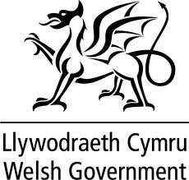
Ann Lukens, Interim Director

Women Making a Difference,

Baltic House, Mount Stuart Square,

Cardiff, CF10 5FH

E-mail: admin@wmad.org.uk Please contact us with any questions!!

Telephone: 02920 493 893

