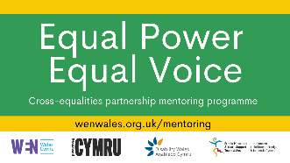 | Equal Power Equal Voice  Public life  mentoring scheme
The Equal Power Equal Voice scheme is run by:

- Women’s Equality Network
 | - Stonewall Cymru
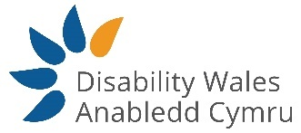 | - Disability Wales
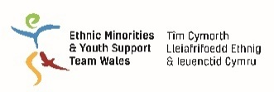 | - Ethnic Minorities & Youth Support Team

Public life
Being involved in public life means having a role or a job where you make decisions that affect your community or the whole of Wales. This includes:
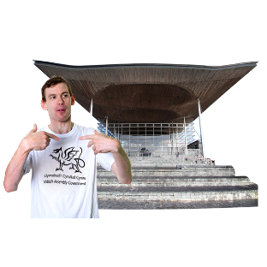 | - Being a politician.
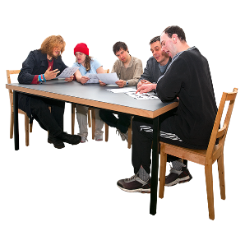 | - Becoming a charity trustee. This means making decisions about how a charity is run.
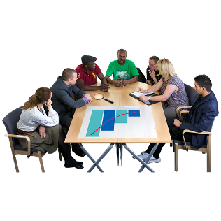 | - Joining a board. This means making decisions about how bosses should run big organisations like the NHS or Sport Wales.
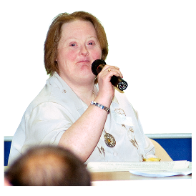 | - Running campaigns to change things.
Mentoring
A mentor is someone who is there for you. They share what they know. They introduce you to people. They support you to achieve your goals.
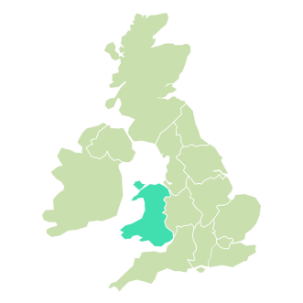 | The scheme is being run because Wales needs more leaders in public life who are:
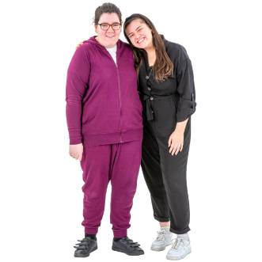 | - Women or
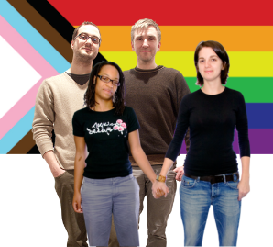 | - LGBTQ* or
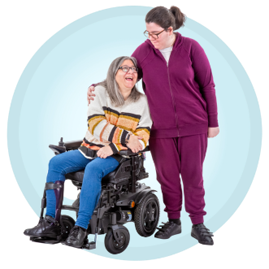 | - Disabled people or
 | - Black, Asian and ethnic minority people.
 | Taking part in the scheme
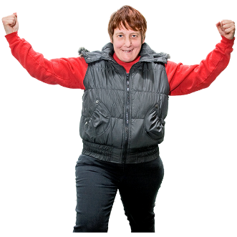 | This scheme can help you get the skills and confidence to get involved in public life.
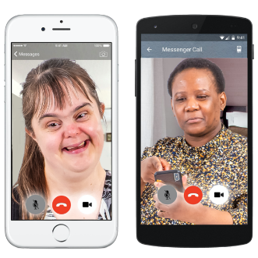 | If you are chosen, you must agree to:  Meet your mentor for 1 hour every 4 to 6 weeks. This can be by phone, video or in person.
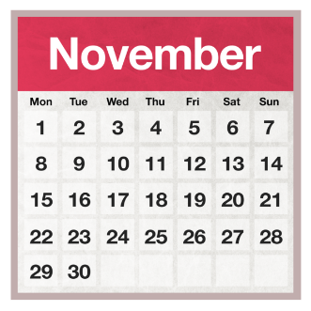 | Take part in online training every month from November 2021 to June 2022. The training will be for 6 hours a month.
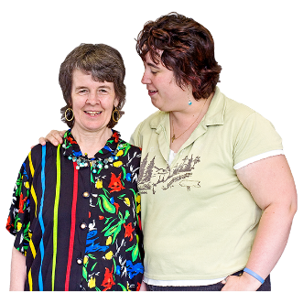 | Take part in a support network where everyone on the scheme can support each other.
The scheme can help you:

- Get more confident and find your voice.
- Know how decisions get made in Wales, and how to influence decisions.

- Know more about how politics work in Wales.
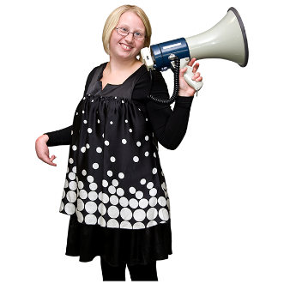 | - Improve your public speaking and how you communicate.
- Meet and speak with influential people.

- Get to know more people who can help you get involved in public life.

 | - Get a job or a role as a politician or public leader.
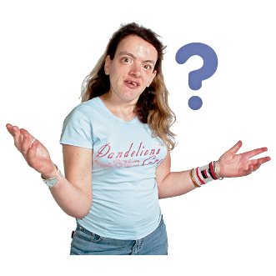 | Who can apply?  You can apply if you are:
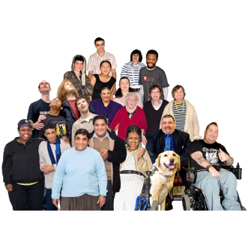 | - Age 18 or older and
 | - Living in Wales and
 | - Wanting to get more involved in public or political life and
 | - Ready to learn how to be a leader
You must also be:

- A Black, Asian or ethnic minority person or

 | - A person from the LGBTQ+ community or
 | - A disabled person or
 | - A woman
 | If you are not sure about applying, you can talk to Ginger Wiegand. Her email is equalpowercymru@wenwales.org.uk. Ask Ginger if you would like to have a chat about this scheme with someone from Stonewall Cymru, Disability Wales or Ethnic Minorities and Youth Support Team.
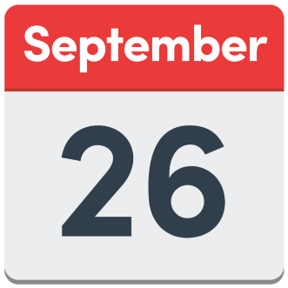 | How to apply  You must apply before 11.59pm on 26th September 2021.
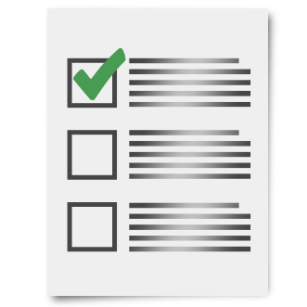 | To apply, you must answer some questions.  You can choose how to answer the questions. You can:
 | - Fill in the online survey: https://forms.office.com/r/x7xdWVkD2S
- Fill in this Word document
Email the document to equalpowercymru@wenwales.org.uk.
 | - Read the questions in this Word document. Then make a 3 to 5 minute video. You need to email or use wetransfer.com to send the video to equalpowercymru@wenwales.org.uk
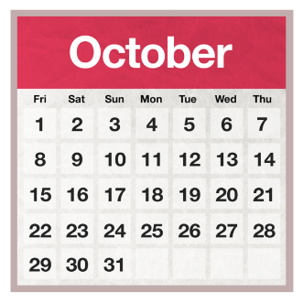 | We will tell you if you have been chosen in early October 2021.
 | Good luck!
Words by Barod CIC.
Pictures from Photosymbols
18th August 2021

