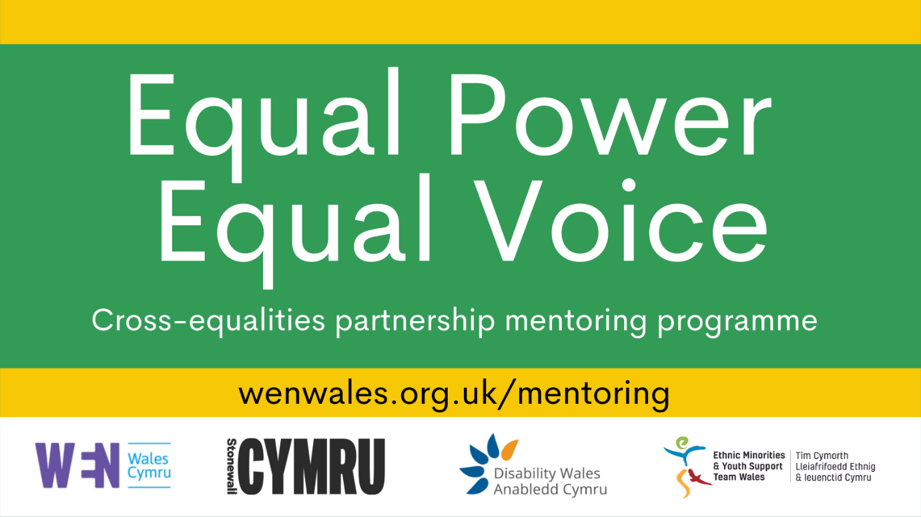

Cross-Equalities Public Life Mentoring Programme

Instructions to apply with video or audio clip

Application to be a mentee for the project round: November 2021-June 2022

Applications open from 23rd August – 26th September 2021

www.wenwales.org.uk/mentoring

Introduction

We are delighted that you would like to apply for the Equal Power, Equal Voice Mentoring Programme.
Through 1-1 mentoring and a series of tailored workshops the scheme aims to enable ethnic minority people, disabled people, women, and people from the LGBTQ+ community to increase their impact and influence in public life and politics. The programme will:
- increase participants’ political understanding of how the Senedd and other levels of government work
- support participants to develop campaigning skills
- develop participants’ confidence in public speaking in a variety of contexts
- provide opportunities to increase networks
- offer specialist training in the areas represented by each partner organisation.

The programme will take place between November 2021 – June 2022.

There is no model candidate we are looking for; however, the following criteria will be taken into consideration by the selection panels. Participants should be able to demonstrate:
- A keen interest in politics, public life, or community activism.
- A desire to develop their contribution to politics, public life, or campaigning
- The ability to tell us clear personal goals and identify skills areas they wish to develop through the programme.
We welcome applications from participants who are at different stages of their political or public life. They must be resident in Wales and over age 18 to apply.

Deadline for applications: 26th September, 11:59pm

You can also email equalpowercymru@wenwales.org.uk for more info or for queries and support with this application.

Privacy & Fair Usage of Personal Data: The information you provide on this form will be used for the sole purpose of processing and evaluating your application and informing you of the results of your application. The personal data you provide in this application will be held on a secure database by WEN and accessible only to project-related staff at WEN Wales, Stonewall Cymru, Disability Wales and Ethnic Minorities and Youth Support Team. After the application process is ended, you will be notified of the results. Information on applications will be archived securely and retained until the Equal Power Equal Voice Project ends in 2024 at which point it will be deleted. For more information: https://wenwales.org.uk/privacy-statement/

Instructions to apply to Equal Power Equal Voice Programme with a video or audio submission:

- Please submit a video or audio clip that is 3-5 minutes long. You can email the clip to equalpowercymru@wenwales.org.uk. Or you can send it through wetransfer.com or through Dropbox.

- Please answer to the following questions in your video/audio clip.

- At the beginning of the video or audio file, please state that you are applying for the Equal Power Equal Voice mentoring programme and that you give WEN Wales and our Equal Power Equal Voice Project Partners (Stonewall Cymru, Disability Wales and EYST) permission to use the information in the video or audio clip to process your application and notify you with the results.

- Contact details- You can share this with us in an email or include them in your clip.
- Your Name
- Your email and/or Mobile number
- City where you live and postcode

- What are your aspirations, goals or areas of interest in political, public or campaigning life? What is it that you want to achieve through participation in public/political life or social activism? (Be specific about the impact you want to achieve, your own goals or what you are interested in. This will help us to find a good mentor match for you.)

- How do you think participating in the Equal Power Equal Voice programme will help your development? In what ways do you hope this programme will benefit you? (Mention any skills, knowledge or networks you want to develop and any barriers you currently face that this programme could help challenge.)

- Please give examples of any previous experience in public life, political life, community activism or volunteering that is relevant to your application. (For example; community work, campaigns with charities or work with political parties. These examples can be paid or voluntary and on any scale, - from your neighbourhood to nationwide. What does your involvement in society look like?)

- What experience, knowledge, skills or networks will you bring to the programme that you could share with other mentees?

- If Politics is your main interest, is there any political party or political parties that you feel most aligned with? You can let us know about any you feel connected to. Or you can skip this question.

- The Equal Power Equal Voice Programme is a partnership of four organisations each with a different focus. Mentees will be based at one of these four organisations where they will do small group sessions that run alongside cross organisation training and networking. Please tell us which of the organisations below that you would like to partner with based on your lived experience and identity. We realise that you may relate to more than one of the partner organisations, in which case, we encourage you to choose a host organisation based on where you think you will feel most comfortable or where you will find the most support for the specific challenges you wish to address by joining this mentoring programme. You can select more than one organisation if you do not have a preference.

☐ Disability Wales is striving to achieve the rights and equality of disabled people in Wales. www.disabilitywales.org
☐ Ethnic Minorities and Youth Support Team (EYST) works to support ethnic minority people as well as challenge negative stereotypes about ethnic diversity in Wales. www.eyst.org.uk
☐ Stonewall Cymru's mission is to achieve legal equality and social justice for lesbian, gay bi and trans people in Wales. www.stonewall.org.uk
☐ Women’s Equality Network (WEN) Wales’ vision is of a Wales free from gender discrimination, where all women and men have equal authority and opportunity to shape society and their own lives. www.wenwales.org.uk

- Do you have any access needs you want to tell us about at this stage? Anything that will help remove barriers to you participating in the mentoring programme? You will also have a chance to answer this question later if your application to be a mentee is successful.

Thank you for completing this application!
You will be notified of the results in early October.

Please one quick favour. Please click this link to fill in our anonymous diversity monitoring survey: https://bit.ly/3kk6jhh

It is very important for us to know if we are reaching all the people that we need to and the diversity monitoring survey helps us to check how well we are doing.

