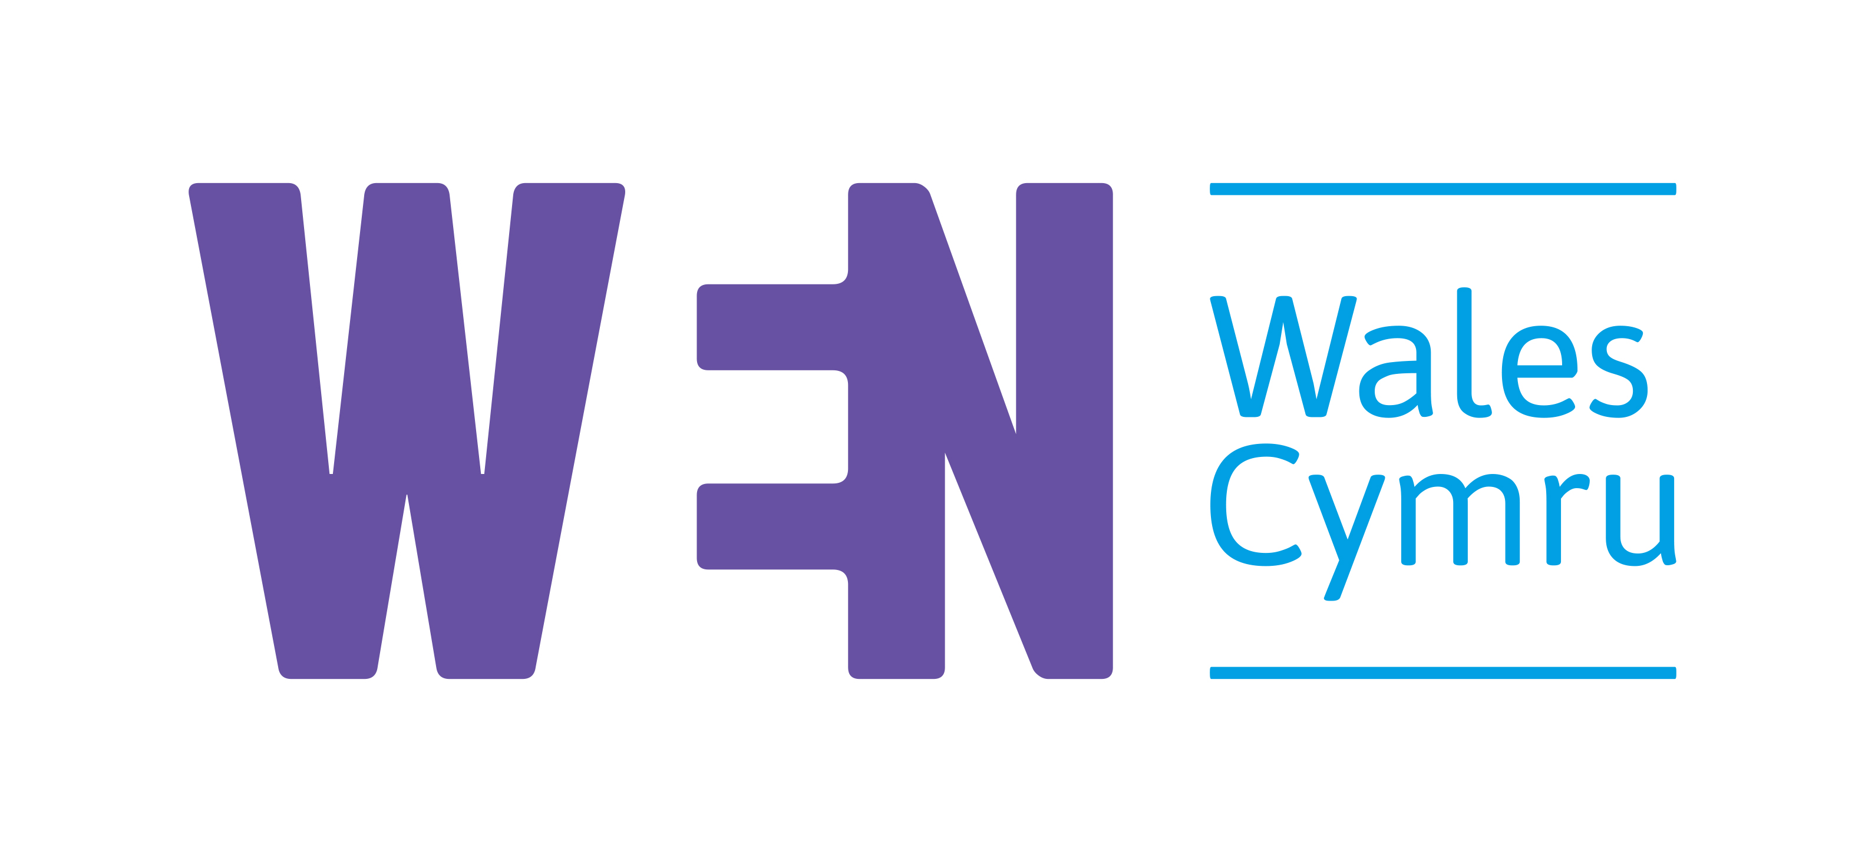

Job Description

Position: Mentoring Project Officer

Salary £27,741 pro rata

Hours: Part Time 3 days / 21 hours per week

Responsible to: Mentoring Project Manager

Responsible for: Mentees
Contract type: Fixed term: Three years until June 2024

Location: Remote, currently working from home

Application Deadline: Monday 5th July, 18:00

We are recruiting four part time Project Officers, one will be based at each partner organisation. The posts will be managed by the Mentoring Project Manager based at WEN Wales, and will be matrix managed by the employing organisation too.

The posts are funded by the National Lottery, Big Ideas Fund.

ABOUT THE PROJECT

The ‘Equal Power, Equal Voice’ Mentoring programme is an exciting new partnership programme which has the potential to transform public life in Wales.
It will recruit and mentor diverse women, BAME people, disabled people, and LGBT people to be involved in public life, whether standing for political office, serving on public boards, charity boards, or as school governors. It has the power to transform Welsh society by supporting diverse people into power so that our political and public institutions better reflect the diverse citizens of Wales.
It builds on previous successful mentoring programmes run by both Ethnic Youth Support Team (EYST) and WEN Wales. We therefore already have a fantastic framework from which to start the project. Both schemes have resulted in mentees becoming Senedd Candidates, MPs, Councillors, public board members, trustees, and school governors

This programme aims to ensure that in the future, decision-makers, politicians, and Government better reflect our increasingly diverse society.
The project is a 3-year project intended to run from July 2021 to June 2024 and is funded by National Lottery and Welsh Government.
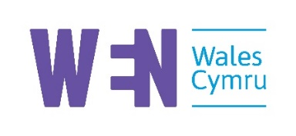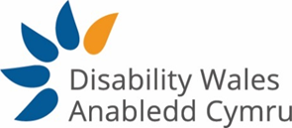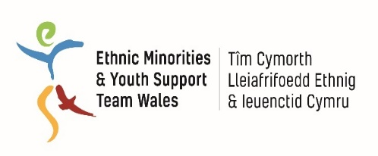

The partnership

We are a group of leading Equalities organisations who have come together to deliver this project to ensure it is truly intersectional. Each of us are leaders in our field:
• Disability Wales is striving to achieve rights, equality, and independent living of disabled people in Wales.
• Ethnic Youth Support Team (EYST) works to support ethnic minority people as well as challenge negative stereotypes about ethnic diversity in Wales.
• Stonewall Cymru's mission is to achieve legal equality and social justice for lesbian, gay, bi, and trans people in Wales.
• Women’s Equality Network (WEN) Wales’ vision is of a Wales free from gender discrimination, where all women and men have equal authority and opportunity to shape society and their own lives.
The lead partner is WEN Wales who have already successfully piloted two mentoring programmes for diverse women.

ABOUT WEN WALES

Our vision is of a Wales free from gender discrimination. Our ambition is a Wales where women and men have equal authority and opportunity to shape their own lives.
We work in coalition with 34k supporters - no one organisation alone can deliver equality. Our work sits under three pillars. We will Connect, Campaign and Champion women until our vision is realised.

ABOUT THE ROLE

This role is about supporting the Project Manager and working with the 3 other Project Officers in delivering the mentoring scheme. You will mainly be involved with recruiting and supporting the cohort of mentees and mentors from your organisation, ensuring they are invited to and attend the main learning events, setting up the peer-to-peer support network for your cohort of mentees, and liaising with the Project Manager.

With a proven track record of delivering projects, you will be dynamic, organised, a good communicator and able to connect people to help them achieve their goals. You will be extremely motivated, able to work on your own initiative and be ready to join a high-performing yet fun and supportive team who are all committed to equality.
We particularly welcome Black, Asian and minority ethnic (BAME) and disabled candidates, as BAME people and disabled people are currently underrepresented in our staff.

Welsh Speaker: Desirable

The Key Objectives of the Role are:

- Supporting the Project Manager in delivery of a successful mentoring programme according to the project plan
- Working with your cohort of mentees to enable them to access the learning programme, benefit from the peer–to–peer support group and from the relationship with their mentor.
Main Tasks will include, but not be limited to:

Project Organisation and Delivery
- Support the Mentoring Project Manager in setting up all systems and lead the recruitment of mentees and mentors from your organisation’s networks
- Match the mentees to appropriate mentors
- Support the organisation of the training events and training sessions by sourcing appropriate speakers, organising zoom sessions and / or physical events
- Organise the peer-to-peer support group for your cohort of mentees
- Work with partners and the Mentoring Project Manager to recruit, liaise with, and keep central register of all possible mentors
- Keep a record of all achievements of mentees as they progress, checking in with them regularly on their learning journey
- Give support to Mentees, as needed, on a case by case basis
- Quarterly reporting and evaluation

Partnership Liaison
- Liaise with the 3 other Project officers and the Mentoring Project Manager to ensure the programme is delivered effectively
- Network widely across the public sector and third sector to promote the project and identify opportunities relevant to the project

External communications
- Be an ambassador for the project, speaking at events where appropriate
- Liaise with the WEN Communications and Engagement officer to help publicise the project.

General Responsibilities and Duties
- Conduct the duties of the job description in accordance with the operational policies of WEN Wales and the partner organisation, including but not limited to: the safeguarding policy, diversity policy, social media policy, data protection policies, home working and other policies.
- Maintain good working relations with all stakeholders, including staff, mentors, mentees, volunteers, Directors / Trustees, partner organisations and Members.
- Contribute to the general administration and delivery of all programmes of your employing organisation, as required.
- Undertake any other reasonable duties as may be required by the role.

Experience | Essential | Desirable
Experience of delivering projects to a high standard. | X
Experience or very strong understanding of what a role in public life entails |  | X
Skills
Proven interpersonal skills and the ability to interact at all levels and ability to enthuse | X
Excellent team work | X
Excellent all-round communication skills including tact and diplomacy to build relationships with political stakeholders | X
Excellent presentation skills and ability to influence audiences in a variety of settings |  | X
Excellent facilitation skills
Excellent time management skills and the ability to produce quality work with minimal supervision | X
Good project management skills | X
Computer literacy, including online meetings and remote working, where applicable | X
Welsh Language  Oral (spoken) and Written Welsh Level B1* (see table below) or evidence to demonstrate an on-going commitment to learn Welsh to this level. |  | X
Knowledge
Knowledge and understanding of equality and human rights issues across all protected characteristics and the barriers and challenges for communities in relation to race, gender, disability or for the LGBT+ community | X
Other requirements
Commitment to anti-discriminatory practice and equal opportunities. An ability to apply awareness of diversity issues to all areas of work. | X
Confident with social media including Twitter, Facebook, etc | X
Lived experience of or demonstrable active allyship with a protected characteristic | X

Terms and Conditions
- 33 days Annual Leave entitlement including bank holidays (pro rata)
- Contributory pension of 5%
- Location: Flexible & Currently working from home
- Salary: £27,741 pro rata
- Contract type – Fixed term: Three years until June 2024
- We are a flexible and supportive employer.

How to apply

Please send a CV along with a supporting letter (no more than 2 sides A4) which addresses the job role and essential criteria, showing how you meet them and telling us why you are the right person for the role. Please also include a sample of published written work (e.g., briefing, report, article, or equivalent in Welsh or English)
Email your completed application to recruitment@wenwales.org.uk by Monday 5th July 18:00.

We will interview on Monday 12th and Wednesday 14th July via Zoom.
If you would like to have an informal discussion about the role, please contact admin@wenwales.org.uk so we can arrange this.

Welsh Language Level | Speaking (interaction and production) | Writing
A0 | I cannot speak Welsh at all. | I cannot write Welsh at all.
A1 | I can:  - interact in a simple way provided the other person is willing to speak slowly, repeat or rephrase things, as well as being willing to help me  - use basic expressions and phrases, e.g. introduce myself or another person,  - ask and answer questions on familiar topics e.g. ‘Where do you live?’. | I can:  - write a short simple message as an email or note, including the time, date, and place.  - fill in forms with personal details, e.g. name, address and telephone number.
A2 | I can:  - communicate in simple Welsh on familiar topics.  - contribute to very short social conversations, even though I cannot usually keep the conversation going myself.  - use a series of phrases to describe and answer questions on my family and other people, the weather.  - convey instructions or very simple telephone messages. | I can:  - write short simple notes and messages, connecting together simple phrases with simple connecting words such as 'and', 'but' and 'because'.  - write a very simple letter or email, e.g. thanking someone for doing something.
B1 | I can:  - take advantage of a range of simple language to deal with most situations which are likely to arise in my work.  - understand the general meaning of emails and letters on topics of personal interest, as well as theoretical letters within the context of my work.  - enter unprepared into conversation on topics that are familiar, e.g. family, hobbies, work, travel and current events.  - offer advice on simple matters to clients within the context of my work.  - describe experiences and events, hopes, and ambitions.  - give reasons and explanations for my opinions and plans concisely. | I can:  - take fairly accurate notes in meetings or seminars where the subject is familiar and foreseeable.  - write letters or emails to describe events, experiences, and impressions.  - write memoranda or informal emails to convey information.
B2 | I can:  - listen to, understand, and contribute to discussions in meetings and seminars.  - take an active part in discussion in familiar contexts.  - clearly express an opinion.  - present clear, detailed descriptions on a wide range of subjects related to work.  - expand and support ideas with supplementary points and relevant examples.  - explain a viewpoint on a topical issue giving the advantages and disadvantages of various options.  - give a clear presentation on familiar topics. | I can:  - write short pieces of business correspondence, as a letter or email, on a wide range of topics related to my work or my field of interest, and this in standard Welsh without using a template (but using a spellchecker, dictionary, technical resources etc. when necessary).  - take notes or write reports, passing on information or giving reasons in support or against a particular point of view.
C1 | I can:  - express myself fluently and unprompted.  - use language flexibly and effectively for social and professional purposes and contribute confidently to meetings and oral presentations.  - formulate ideas and opinions and ensure that my contributions are relevant to others.  - respond appropriately to different cultural and social situations.  - present clear detailed descriptions of complex subjects, integrating sub-themes, developing particular points, and rounding off with an appropriate conclusion. | I can:  - write clear well-structured texts, expressing points of view at some length.  - write detailed explanations of complex subjects in the form of email, letter, essay, or report, underlining the salient issues.  - write different types of texts in styles that are appropriate to the reader in mind.

